Key aspects of industry 4.0

Industry 4.0 is affecting companies exponentially ,touching every sector profoundly .While we continue embracing innovative advancements , we must be familiar with certain key aspects of Industry 4.0.

As we know that the fourth industrial revolution is not just a specific technology but a convergence of multiple technologies.In this article we are going to understand Cyber Physical Systems(CPS) and some of the properties common in every technology used in Industry 4.0.

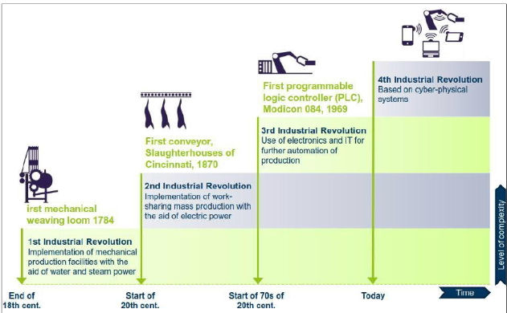

The term Cyber Physical System was coined by Helen Gill around

2006. Simply stating , it is a system of systems with diverse properties . They are systems supported by intelligent machines that control and interact with a physical process and adapt to new situations in real time. Some of the resilient features of the CPS that play an important role in its implementation are-

1)Interoperability – The Cyber-physical systems requires amalgamation of heterogenous technologies and tools and thus interoperability becomes a key feature , which is defined as the ability of a system to operate with the parts of other systems involved.

2)Decentralization- In Industry 4.0 ,decentralization means that even if the functions and powers are dispersed over an organization away from a central authority , the machine doesn’t depend on human interference for its working. The decisions can be automated based on performance data.

3)Real-Time Awareness- CPS are expected to manage tremendous amounts of data within a time constraint. This real-time data and analysis provides quicker responses to problems and even predicts maintenance.

4)Modularity – Creation of sub-systems or modules with well defined interfaces allow companies to to switch to any production line activity or even manufacture unique products without affecting or having to reconfigure the whole assembly line.

5)Virtualization -Virtualization is creating a virtual version of something to reduce the number of physical machines that enables one to run more workloads on a single server. Machines that use virtualization are less prone to be attacked by virus and can perform a multitude of tasks on their own without using a physical version of that thing.

yber Physical Production

Systems (CPPS) and Industry 4.0

yber Physical Production

Systems (CPPS) and Industry 4.0

r Physical Production

Systems (CPPS) and Industry 4.0

Cyber Physical Production Systems and Industry 4.0

Combination of cyber and physical systems open doors to creation of new growing markets and allows the emerging of advances that promotes engine for a wider range of industries.

CPPS comprise autonomous and modules that connect with each other , on and across all levels of production, from processes through ,machines up to production and logistics network.

Concepts of CPPS along with some other technological systems make the base of Industry 4.0 by enabling the capturing of data through integrated sensors and measurement systems in real time. The function of a CPP is to process raw material to define , speed up and setting the objectives and the corresponding functionalities with the help of a Production Planning Software.

Building blocks of CPPS

~Cyber Physical System

~Cyber Physical Transportation System(CTPS)- a subset of CPA that enables an Intelligent Transportation System to provide for security , reliability and increased productivity.

~Manufacturing Execution System-system for keeping track of manufacturing information in real time.

